Why Do Customers Leave? Can You Spot The Churners?

SQL queries

1.what is the maximum total charges recorded in the payment information?

select max(total_charges) as max_charge from payment_info;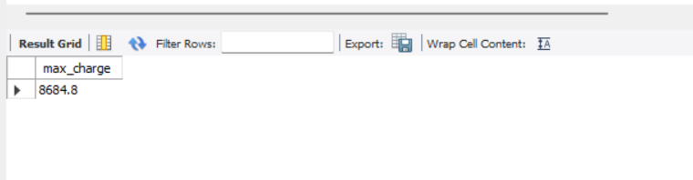

2. what is the total revenue generated for each type of internet services?

select sum(p.total_revenue) as total_revenue, s.internet_service from payment_info p join service_options s on s.customer_id=p.customer_id group by s.internet_service;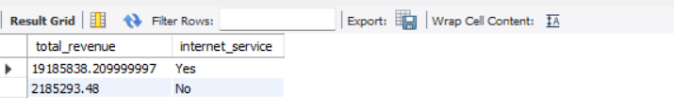

3.List customers who referred the most friends?

select s.customer_id, s.number_of_referrals from service_options s order by s.number_of_referrals desc limit 10;

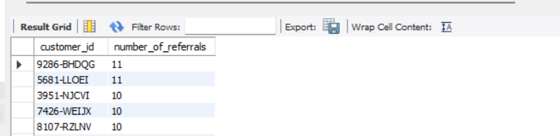

4.calculate the total revenue generated by customers in each city?

select l.city, sum(p.total_revenue) as total_revenue FROM location_data l join payment_info p on l.customer_id = p.customer_id group by l.city;

